1. User Interface Creation Process:
- Wireframing: Low-fidelity mockups created for Main Menu, In-game HUD, Detective Notebook, Dialogue Overlay, and Accusation Screen.
- Asset Styling: Styled UI components using a noir brown/leather paper texture for the Detective Notebook and minimalist white/gold text for HUD popups.
- Unity Canvas Setup: Implementation using Unity UI Canvas with Scaler set to Scale With Screen Size (1920x1080 reference resolution).
- Event Binding: C# Event Listeners hooked to UI buttons, dialogue option triggers, item inspection popups, and clue unlock notifications.
DFD Level 0
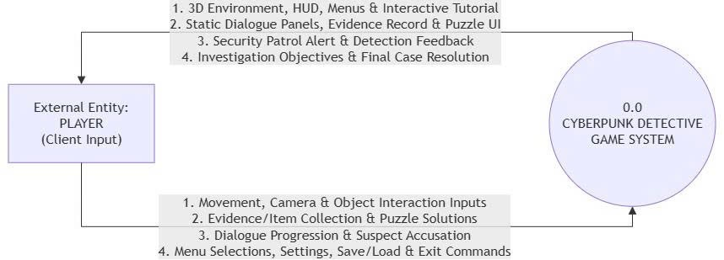
DFD Level 1
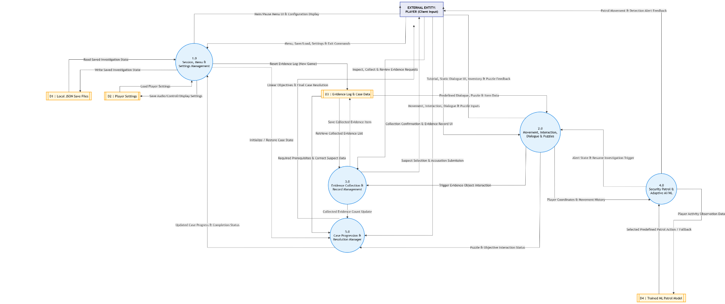

2. Functionality of User Interface and Elements:

UI Component | Elements | Functionality
Main Menu | New Game, Load Game, Settings, Quit | Starts investigation, loads JSON save file, adjusts resolution/volume, exits app
Investigation HUD | Reticle, Interaction Prompt ("Press E"), Notification Banner | Displays crosshair, shows interactable object names, displays "New Evidence Added" alerts.
3D Item Inspection View | 3D Model Viewer, Rotate/Zoom Controls, Description Panel | Renders selected evidence in 3D overlay, allows player to rotate item to find hidden marks.
Detective Notebook (Tab Key) | Evidence Tab, Suspects Tab, Sequence Tab, Accuse Button | Displays 5 collected clues, shows 4 suspect profiles, allows linking clues to statements.
Dialogue Overlay | Speaker Portrait, Nameplate, Dialogue Text, Choice Buttons | Displays NPC speech, allows player to select interrogation questions or present evidence
Puzzle UI Overlay | Interactive Cipher Dial / Jigsaw Pieces, Reset Button, Exit | Modal window for solving puzzle; updates inventory upon solution
Final Resolution Screen | Suspect Selection List, Confirm Accusation, Verdict Video/Text | Player selects final culprit; displays success sequence if correct suspect chosen, or failure outcome if wrong

Submission Date: | September 29 2026
Student Name: | Trịnh Tấn Lộc
Trainer Name: | Nguyễn Hồng Sơn

